**Practical 8**

Q1

**CODE:**

<?php

$a=10;

$b=20;

$n=$a+$b;

echo"Addition of ".$a." and ".$b." is ".$n;

?>

**OUTPUT:**

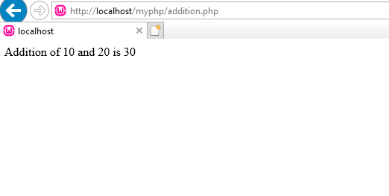

Q2

**CODE**:

<?php

$a=1;

while($a<=10)

{echo$a."<br>";

$a++;}

?>

**OUTPUT:**

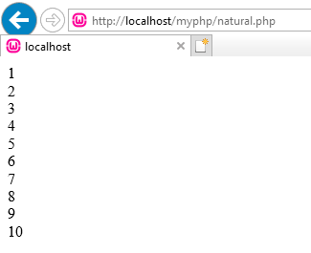

Q3

**CODE:**

**username.php**

<?php

$n=$_REQUEST["uname"];

echo "You entered:".$n;

?>

**username.html**

<html>

<body>

<center>

<h1>Sending Data to Text Field </h1>

<form method="POST"action="username.php">

Enter your name:

<input type="text" name="uname"><br>

<pre><input type="Submit"

value="Click"></pre>

</form>

</center>

</body>

</html>

**OUTPUT:**

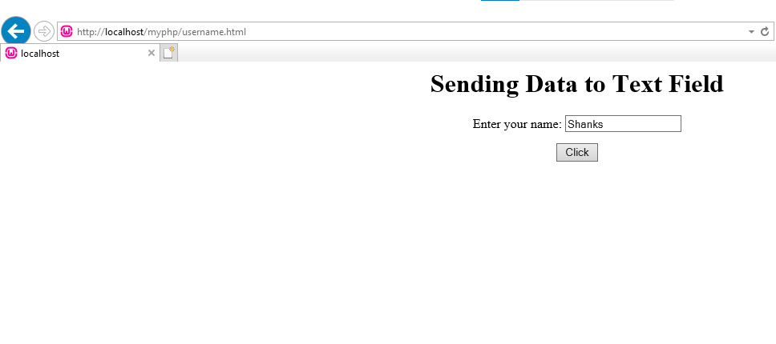



Q4

**CODE:**

**evenodd.html**

<html>

<body>

<center>

<h1>Sending Data to Text Field </h1>

<form method="POST"action="evenodd.php">

Enter number(to know even or odd):<br>

<input type="text" name="num"><br>

<pre><input type="Submit"

value="Click"></pre>

</form>

</center>

</body>

</html>

**evenodd.php**

<?php

$n=$_REQUEST["num"];

if($n%2==0)

{

echo $n." is Even number";

}

else

{

echo $n." is Odd number";

}

?>

**OUTPUT:**

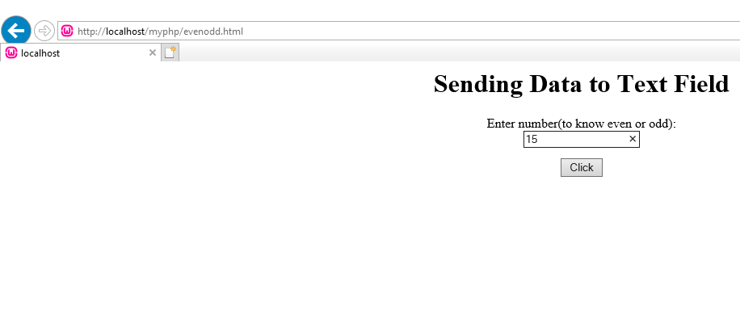

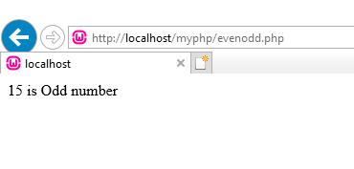

Q5

**CODE:**

**fact.html**

<html>

<body>

<center>

<h1>Sending Data to Text Field </h1>

<form method="POST"action="evenodd.php">

Enter number(to know even or odd):<br>

<input type="text" name="num"><br>

<pre><input type="Submit"

value="Click"></pre>

</form>

</center>

</body>

</html>

**fact.php**

<?php

$n=$_REQUEST["num"];

$f=1;

for($i=1;$i<=$n;$i++)

{

$f=$f*$i;

}

echo "The factorial of ".$n."is ".$f;

?>

**OUTPUT:**

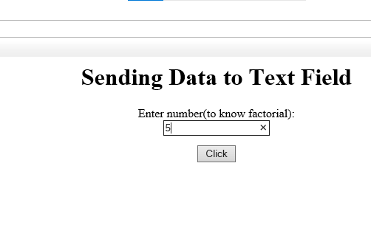

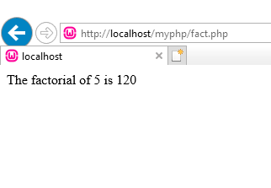

Q6

**CODE:**

**num.html**

<html>

<body>

<center>

<h1>Sending Data to Text Field </h1>

<form method="POST"action="num.php">

Enter number(to know natural number sum):<br>

<input type="text" name="num"><br>

<pre><input type="Submit"

value="Click"></pre>

</form>

</center>

</body>

</html>

**num.php**

<?php

$n=$_REQUEST["num"];

$s=0;

for($i=1;$i<=$n;$i++)

{

$s=$s+$i;

}

echo "Sum of first ".$n. "Natural number is ".$s;

?>

**OUTPUT:**

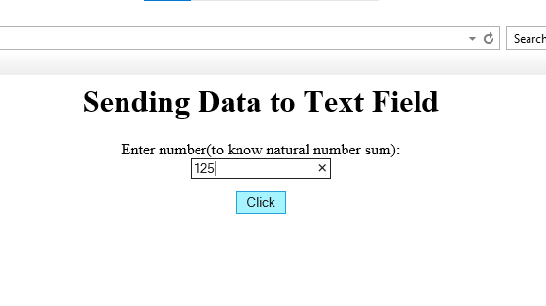

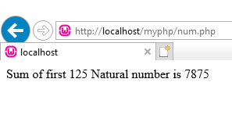

Q7

**CODE:**

**sum.html**

<html>

<body>

<center>

<h1>Sending Data to Text Field </h1>

<form method="POST"action="sum.php">

Enter number(to know sum of them):<br>

<input type="text" name="num"><br>

<pre><input type="Submit"

value="Click"></pre>

</form>

</center>

</body>

</html>

**sum.php**

<?php

$n=$_REQUEST["num"];

$sum=0;

echo "Sums of digits ".$n." is ";

while($n>0)

{

$r=$n%10;

$sum=$sum+$r;

$n=$n/10;

}

echo $sum;

?>

**OUTPUT:**

